

The Breitling Fighter Challenge is managed by:



The Stable Block, Back Lane
Fairford GL7 4AG
Tel: 01285 711111 Fax: 01285 711222
Email Breitling@Eventuality.co.uk

THE BREITLING FIGHTER CHALLENGE

This document provides all the necessary information on hosting a Breitling Fighter Challenge. Hopefully it will answer all of your questions, but if you do require further details, please do not hesitate to contact the management company – Eventuality UK Ltd.

The Fighter Challenge is adaptable and is suitable for all types of event from large public exhibitions to hospitality days and private in-house functions. As long as the space and power are provided the Challenge is largely self-contained. A number of staff will be supplied to match the demands of each event.

At the end of this document you will find a booking form. Please print it out, fill in as much detail as you can, sign it and fax or send it to the marketing department at Breitling head office.

The Concept

The Breitling Fighter Challenge provides a high quality air combat simulation experience based on the latest technology and software. Participants will enjoy a unique level of adventure way beyond the normal home gaming experience but without the need for professional simulation equipment.

The challenge set-up consists of two combat stations each capable of solo action or a head to head battle between the two. Stations consist of a bucket style seat with accessories to create the image of a fast jet seat, a joystick between the knees with separate throttle at the left hand and three plasma screens providing the visual images.

The chosen mission is based on an F-15 dogfight situation. You will have a supply of Aim-9 missiles and unlimited cannon rounds. Your flight will start at approximately 1500ft, traveling at 250 knots and your enemy will be half a mile ahead of you. The aim is to find your enemy and shoot them down before they shoot you.

The Software

The Breitling Fighter Challenge uses the Eagle Dynamics Lock-On Modern Air Combat software. This is a highly respected air combat experience and one of the only software packages capable of supporting the three-screen signal split.
The Black Sea region, which includes the Crimean peninsula and the eastern Caucuses, is the setting for the hypothetical, present day air conflict. Stunning 3D objects and terrain create the best looking world ever created for a flight simulation. Everything from aircraft, to tanks, to buildings, are recreated in unmatched detail. There is an incredibly detailed battle area with dynamic lighting effects featuring, more than 180,000 buildings, 50,000,000 trees, 21 cities, 1,700 towns and villages, 500 bridges, 18 airfields and 8 naval bases. The experience includes realistic sound effects and audio environment that includes communication with wingmen, AWACS, tankers, and tower/approach controllers.
Scalable realism and difficulty levels for the beginner and expert pilot are included. For example, options for extra-powerful engines, anti-spin control and easy landings make it more accessible for beginners.

The Equipment

Screens - Seven Panasonic TH42PWD6 42” plasma screens

Computers - PCs have been tailor made for the Breitling Fighter Challenge. Components have been chosen to ensure that the performance of the machine is geared to making the most of the software and the graphics card.

Controls - The Breitling Fighter Challenge uses the Saitek X52 system. This provides a split joystick / throttle set-up enabling us to locate the controls correctly to provide a more realistic experience.

Graphics Cards - The Breitling Fighter Challenge employs one of the only cards capable of supporting the three-screen signal split - the Matrox Parhelia 512.

Seats - Seats have been specially adapted using the base frame from road racing simulation equipment. Professional race seats, correct throttle and joystick positions and footplates create a highly realistic flying experience.

Extras

In case of malfunctions or breakages, we do hold spares for most of the equipment. As an added extra, when they are not required, some of these spares can be employed to enhance the Fighter Challenge set-up as follows:

Plasma screen - One spare is available. This will normally be positioned between the stations and is used to provide the contestants with a map overview of their activities.

PCs and monitors - At larger events (particularly public exhibitions etc), two spare PCs, two spare 15” monitors and spare joysticks and throttles can be used as a separate training area.

PLEASE NOTE: Should any of the main Fighter Challenge equipment fail these spares may be required to maintain normal operations.

Backdrop - There is a 20ft x 8ft banner that can be installed to form a backdrop to the Fighter Challenge If this is required, suitable fixing points should be made available. Please call Eventuality UK for further information.

Set-up Requirements

Space - The full set-up requires a minimum of 20ft x 10ft (7m x 3m) of flat floor surface. This does not include any area for spectators.

- If the training area is to be employed, we shall need another area of 9ft x 6ft (3m x 2m) which should be located adjacent to the main Fighter Challenge set-up.

Floor loading - The maximum loading of the Fighter Challenge (including operators and contestants) is approximately 800kgs. If the Challenge is to be set up on a temporary floor, this should be flat and level (marquee matting is not suitable – boards should be installed).

Power - A minimum of two separate fully rated 13 amp supplies are required for the main set-up. A third is needed if the training area is employed.

Time - If the delivery vehicle can get next to the installation, the basic Fighter Challenge takes approximately 2 hours to set up. If the training area is required, please allow an extra 30 minutes and if the backdrop is required, another 30 minutes. Please note these timings are approximate and can be significantly influenced by awkward loading routes such as stairs etc. Similar times should be allowed for the de-rig.

Parking - Parking should be available for a long wheel-base Transit style van for the duration of the event.

Light - We have successfully run the Breitling Fighter Challenge in all types of environment. However, if the set-up can be located away from direct sunlight, it does provide a better visual experience for the contestants.

IMAGES

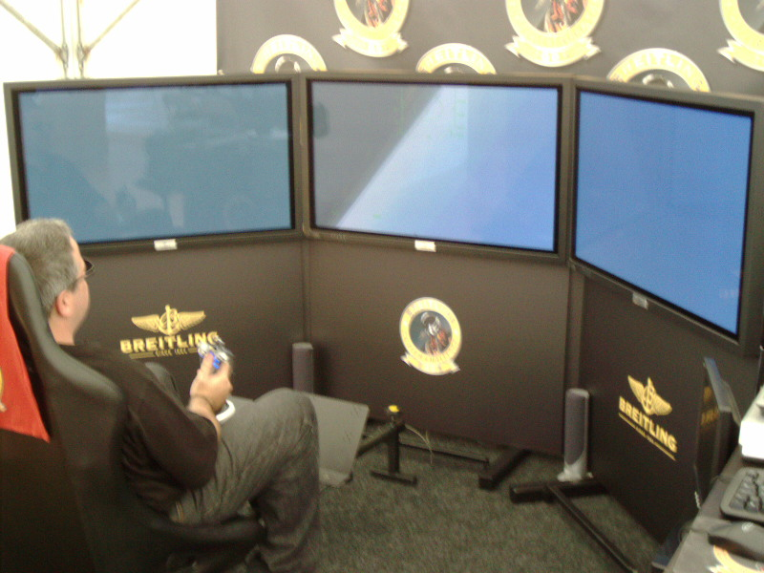
Single Station

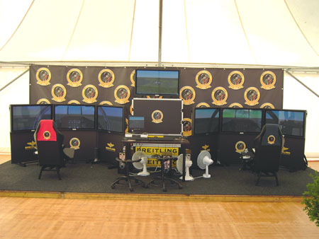
Full view

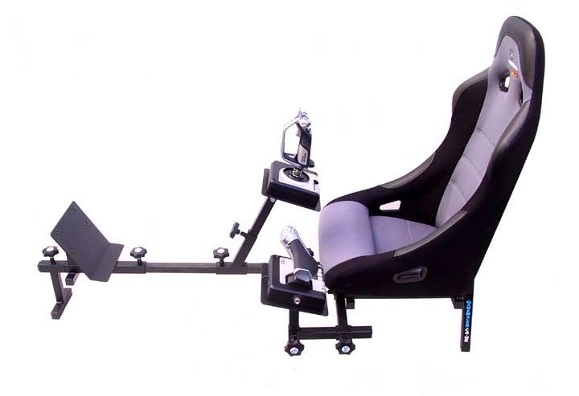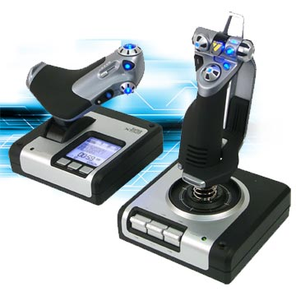
Seats and Controls


The Stable Block
Back Lane, Fairford
Gloucestershire, GL7 4AG
Tel: 01285 711111
Email: BFC@Eventuality.co.uk
Suite 5.02, Fifth Floor
Morley House, 314 – 322 Regent Street
London W1B 3BG
Tel: 0207 636 5200
Marketing.Breitling@BTInternet.com

EVENT BOOKING FORM
TO ENSURE THAT YOUR BREITLING FIGHTER CHALLENGE IS STAGED AS EFFICIENTLY AND EFFECTIVELY AS POSSIBLE, PLEASE SUPPLY THE FOLLOWING INFORMATION. PRINT THE FORM OUT, COMPLETE IT AND SEND VIA EMAIL OR FAX TO BREITLING HEAD OFFICE

Event name, description and numbers attending?

Event location?

Event dates?

What are the daily operational times for the Challenge?
What is the earliest time we can start the set-up?
By what time do we have to be cleared out?

Will unloading/loading assistance be available?

How close can the delivery vehicle get to the set-up area?
Are there steps / stairs / lifts etc?

Do you require the Training PC set-up?

Do you require the backdrop? If so, are there suitable fixing points available?
Will parking be provided for the van, if so where?

Will there be two separate fully rated 13amp power supplies available nearby? (NOTE: Three supplies will be required if you want the training PCs.)



Continued….Event name and date………………………………

Will there be a minimum of 20ft x 10ft (7m x 3m approx) space available? (NOTE: Extra 3m x 2m required for training PCs)
The total floor weight loading should not exceed 800 kg. Will this pose a problem?
If the Challenge is to be left overnight, is there security cover available?
Do you require a video / audio feed to any external equipment?
If the event is over more than one day, or if the start / finish times are early / late, is accommodation available?
Are passes required to gain access to the event and if so, who will provide them?

Please provide contact details for the event organiser or the person we need to contact on our arrival.

Booked for and on behalf of Breitling UK by: | Print name  Sign  Date

